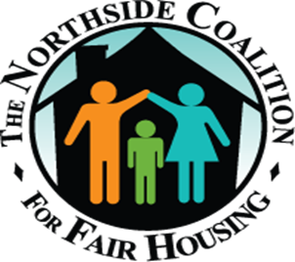

Dear Northside Property Resident,

Northside Properties will be issuing fines regarding improper disposal of trash. For the first offense you will be issued a 25.00 fine, second offense is 50.00. To avoid the possibility of a fine
PLEASE DO NOT:
- Leave your garbage next to the dumpster or outside trash cans.
- Hanging on back of steps and front steps.
- Litter in surrounding yard.
- Dragging the trash to dispose.
Reminder if your kids can not reach the dumpster please assist them with putting the garbage in properly. Remember you are responsible for your family and guest so let’s work together to keep our neighborhood clean and rodent free.
If you have any more questions, feel free to contact Your Community Liaison NCFH at 412-321-5527
Thank you

